The VIP Journey Storyboard

Student Name
Course Name
Department Name
Date

✨ THE VIP JOURNEY STORYBOARD ✨
Part 1 — From Fertilization to Implantation

THE 5-PANEL JOURNEY
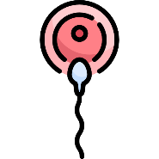  FERTILIZATION  Sperm meets egg in the oviduct — the ultimate VIP meet-up!  The Star Performer arrives at the VIP Meet-Up |   ZYGOTE  Fertilized egg with 46 chromosomes — a single diploid cell beginning its journey.  🎭 VIP access granted — the Star's name is on the list! | 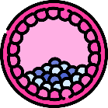  BLASTOCYST  Cell division forms a hollow ball of ~100 cells, traveling to the uterus.  The entourage grows — the tour bus is rolling!

 | 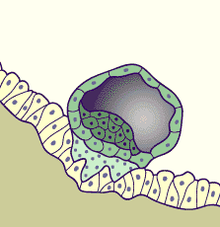  IMPLANTATION  Blastocyst embeds into the endometrium — now officially a resident of the Royal Suite.  🎭 Checked into the Royal Suite (uterus) — 5-star luxury! | 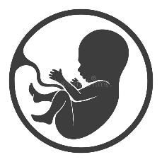  PLACENTAL FORMATION  Placenta forms — delivering oxygen and nutrients via the umbilical cord.  🎭 Catering & Data Supply team is fully operational!

PALACE INFRASTRUCTURE MAP
TESTES | Recruitment Center | OVARIES | The Gem Vault
UTERUS | The Throne Room | FALLOPIAN TUBE | VIP Corridor

CATERING & DATA SUPPLY TEAM
PLACENTA  Exchanges nutrients, oxygen & waste between mother and fetus via the endometrium | UMBILICAL CORD  The direct data line — connects fetus to placenta, delivering all essential supplies

