Ecosystem Energy Map & Climate Risk: The Pond Ecosystem at Southern University A&M College

[Student Name]
Southern University A&M College
SBIO 102B – Biology in My HBCU Community
[Instructor Name]
April 5, 2025

Ecosystem Energy Map & Climate Risk: The Pond Ecosystem at Southern University A&M College
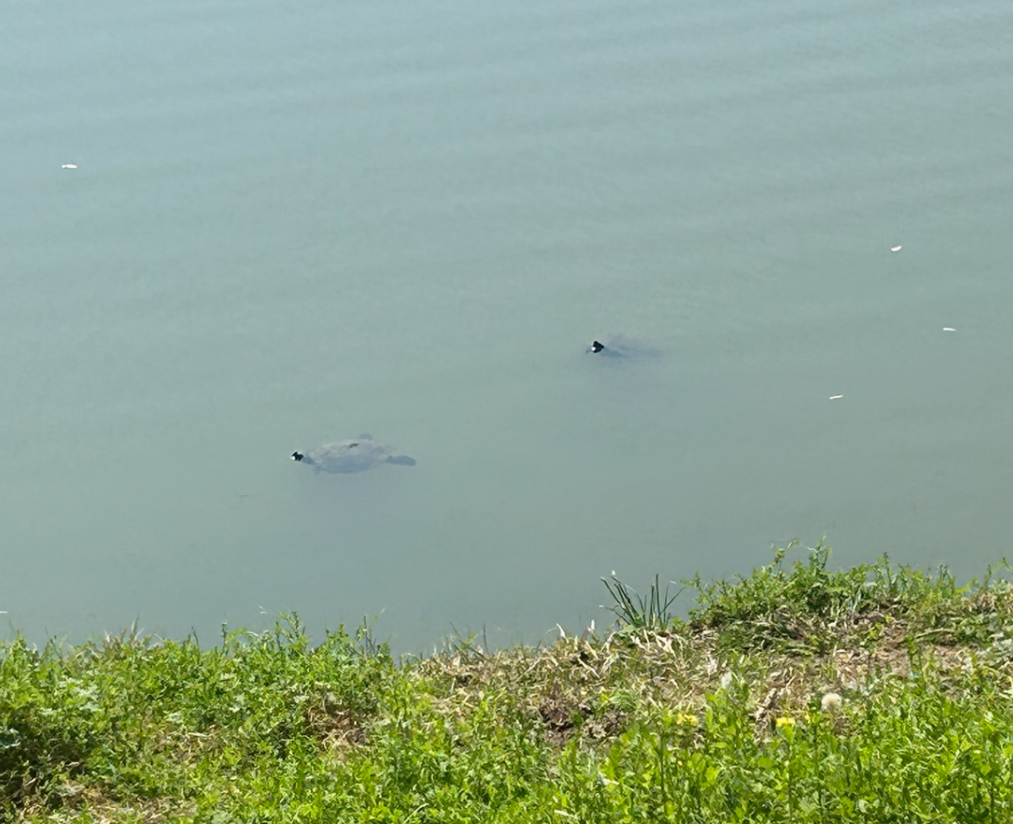
Figure 1: Turtles observed swimming near the shoreline of the campus pond at Southern University A&M College.
The pond in front of the Mayberry Cafeteria of the Southern University A&M College is not just a decoration of the campus. It is a self-sustaining ecosystem in which energy flows from one living organism to another. In a recent observation, two turtles were observed as they were swimming close to the shoreline (Figure 1), and this aspect made one have a closer look at the ecological relations that are in operation in this small yet meaningful body of water. This portfolio item will trace the energy flow in the pond ecosystem and explore how climate change can destabilize the ecosystem in one way.
Energy flow in the Pond Ecosystem.
The producers are at the bottom of this ecosystem; they are algae and aquatic plants that grow at the shore of the pond. As it has been recorded in Module 1, algae in this pond are concentrated along the edges, creating a layer of green substance which traps sunlight and transforms it into chemical energy through photosynthesis. Campus runoff contains nutrients such as nitrogen and phosphorus; this growth increases algae as the basis of energy in all life throughout the pond.
The algae and plants are directly fed by the primary consumers that include zooplankton, snails, and aquatic insects. The turtles in Figure 1 are used as the secondary consumers. Being omnivores, they consume aquatic plants, invertebrates, and small fish, which makes them occupy the intermediate position in the energy pyramid. Wading birds like herons, which are at the top of the local food web, can come to the pond to feed on fish and other animals. The pond sediment has bacteria and fungi that act as decomposers, and they help to break down the dead organic matter and recycle the nutrients back to the producers, thereby closing the energy cycle.
Climate Change Effect: Heat Stress and Dangerous Algae Blooms.
One of the main climatic threats to this ecosystem is the increase in water temperatures due to the increase in average temperatures in the air in Louisiana. Warm water enhances the growth of algae faster than usual, leading to harmful algae blooms. The algae multiply at a high rate and consume the dissolved oxygen in the water by a process known as eutrophication, and it makes the environment inhabited by fish, turtles, and invertebrates uninhabitable. Particularly endangered are the turtles that can be seen in this pond because reptiles rely on consistent temperatures in the water to maintain their body heat and locate shallow waters with oxygen. The disturbance of this intermediate level in the food web is transmitted both up and down the food chain, endangering the birds that nest here and disrupting the invertebrate populations checked by turtles.
Relationship with the Last Module.
Algae and turtles are some of the constituent species in this ecosystem, which is related to the population that I researched in Module 1, in that they are found in the same habitat, the campus pond. In the first module, algae had been analyzed as an independent population that was influenced by sunlight, nutrients, and environmental factors. In Module 2, the same algae population is perceived as the producer level of a larger food web that supports turtles, invertebrates, and visiting birds. An extension of the population to the ecosystem perspective shows the extent to which the life on the Southern University A&M College campus is interconnected.

