Maternal Immune Activation and Genetic Risk in Autism
Senior Investigative Paper
Presented in Partial Fulfillment of the Requirements
Of the Bachelor of Science Degree in Biology
In the Department of Natural Sciences and Mathematics
Johnson C. Smith University
By Zaqoya Richardson
Fall, 2025

Committee: Approved by: Date:

Primary Reader: Dr. Tracy Brown-Fox

Secondary Reader: Dr. Sunil Gupta

Department Chair: Dr. Ricardo Phipp

Table of Contents
ABSTRACT 4
INTRODUCTION 5
BACKGROUND 5
HYPOTHESIS 7
UNDERSTANDING AUTISM SPECTRUM DISORDER 8
MATERNAL IMMUNE ACTIVATION 11
KEY STUDIES ON THE RISK OF AUTISM 13
GENE-ENVIRONMENT INTERACTION: GENETIC RISK 15
GAPS IN RESEARCH 17
CONCLUSION 18

ABSTRACT

Autism spectrum disorder (ASD) is a highly prevalent and heterogeneous neurodevelopmental disorder. Previous research on this disorder has mainly focused on the highly heritable nature of genetic risk; however, the incomplete penetrance associated with the vast majority of genetic risk variants indicates that genetic risk does not fully explain the etiology of ASD. This review synthesizes the existing literature and assesses the dual-hit hypothesis of ASD (interplay between polygenic risk and maternal environmental exposures (i.e., maternal immune activation or MIA).

Extensive evidence from epidemiological studies and empirical studies using murine and/or human cellular models supports that increased levels of inflammatory mediators, including IL-6 (interleukin-6) and IL-17a (interleukin-17a) from the mother during periods of severe inflammation result in neuroinflammation in the offspring via passage through the maternal-fetal interface and alter the epigenetic landscape of the developing fetal brain (i.e. synaptic pruning and neuronal connectivity). Additionally, numerous studies have reported the sex-specific differences in physiological response to maternal immune activation, providing a biological basis for the disproportionate occurrence of ASD in males. Ultimately, this review underscores that the phenotypic heterogeneity of ASD is driven by the complex interplay between a fetus's genetic architecture and its gestational immune environment. Addressing key knowledge gaps in translational models and identifying the precise mechanisms that confer neuro-immune resilience will be critical to developing precision therapeutic interventions for individuals who are neurodivergent.

INTRODUCTION
Autism spectrum disorder (ASD) is a complex neurodevelopmental disorder that is characterized by deficits in social communication and social interaction that are persistent over time, alongside restricted/repetitive patterns of behavior, interests, or activities. The prevalence of ASD around the world has been increasing over the last few decades and has led to considerable research into its underlying etiology. Historically, autism has been viewed through a deterministic genetic lens. Moreover, family studies have provided consistent evidence supporting a high heritability for autism, highlighting the significant role that genetics plays in the onset of this disorder (Tang et al., 2025). However, while genetic variants are important, there is also considerable phenotypic variability, and the spectrum of severity associated with autism has increased across different populations, thereby clarifying the fact that genetic susceptibility is insufficient to trigger the onset of autism. Furthermore, studies have identified that genetic and environmental risk factors contribute to ASD's etiology, such as disruptions that could occur during the prenatal period and may contribute to neurodevelopmental vulnerability (Tang et al.,2025; Mirabella et al., 2021).

BACKGROUND
Over recent years, researchers have been focusing on the maternal-fetal relationship for evidence of environmental factors that may influence the developing fetus. The focus has primarily been on the maternal immune system. As reported by numerous studies, severe maternal illness during pregnancy is associated with a higher incidence of developmental disabilities (e.g., ASD) in children (Levchenko et al., 2021). Disruption to the development of the fetus due to an inflammatory response from the mother's immune system (referred to as Maternal Immune Activation [MIA]) can occur when there is an inflammatory response to any of the following conditions: pathogens (e.g., viruses), stress, and/or autoimmune activity. As a result of this response, pro-inflammatory cytokines (e.g., IL-6, IL-17a) are released into the mother's body and may cross the placenta to induce neurodevelopmental changes in the fetus due to their impact on placental function. Tang et al.'s comprehensive review (2025) illustrates that maternal immune activation is biologically and physiologically related to pathophysiological changes in offspring that may alter neurodevelopment. Many animal studies support this clinical evidence: offspring exposed to immune activation during the prenatal period exhibit many behavioural and physiological characteristics that are consistent with autism (e.g., ASD)-associated behaviours, including altered gut microbiota composition (Tartaglione et al., 2022). In addition, there are specific experimental models that demonstrate how increased cytokine levels (e.g., IL-6) during the prenatal period induce a reduction in the number of hippocampal synapses and cause abnormal synaptic density (i.e., glutamatergic synapses). Ultimately, MIA-induced disruptions of neurodevelopmental processes are expected to result in abnormal neural connectivity (Mirabella et al., 2021).
MIA may produce both structural changes (e.g., hypomyelination) and social behavior deficiencies that are strikingly similar to the physiologic features typically associated with human ASD (Lee et al., 2021). Furthermore, although a number of epidemiologic studies provide strong evidence for a link between MIA and abnormal brain development, not all children whose mothers are diagnosed with severe systemic infections during pregnancy will develop ASD (Tang et al., 2025). Thus, this disparity suggests that there may be an interaction between the maternal immune response and genetics in producing ASD, often referred to as the "dual-hit" model in neurobiology. In the dual-hit model, the first hit (i.e., genetics) produces an underlying vulnerability (e.g., developmental, molecular) in the brain, and the second hit (e.g., maternal immune activation) acts as a catalyst and disrupts the trajectory of neurodevelopment. For example, maternal cytokines such as IL-17a have been shown to produce different effects on the neuronal differentiation of neural progenitor cells derived from autistic versus non-autistic individuals, which demonstrates how genetic variability in an individual's genetic background influences how their neural progenitor cells respond to the prenatal immune system (Gomes et al., 2022). The differences seen in the response to immune activation, which include highly specific molecular and behavioral features that are sex dependent and indicate the complexity of the interaction between the maternal immune response and genetics in producing ASD (Xu et al., 2024).

HYPOTHESIS
This investigative paper operates under the central hypothesis that Maternal Immune Activation (MIA) and genetic susceptibility do not act independently, but rather exhibit a synergistic gene-environment (G x E) interaction in the etiology of Autism Spectrum Disorder (ASD).
Specifically, the literature is expected to support the following targeted hypotheses:
- Primary Hypothesis: Individuals with underlying polygenic risk factors for ASD who are concurrently exposed to elevated prenatal maternal pro-inflammatory cytokines (such as IL-6 and IL-17a) will demonstrate a significantly higher incidence and severity of ASD-related neurodevelopmental deficits compared to those exposed to either genetic risk or MIA alone.

UNDERSTANDING AUTISM SPECTRUM DISORDER
Autism Spectrum Disorder (ASD) is a pervasive and heterogeneous neurodevelopmental disorder marked by impairments in social communication and reciprocal interaction, beginning at a young age, along with limited, repetitive behaviours, interests, or activities. The clinical presentation of ASD in current diagnostic frameworks is considered to be on a "spectrum", due to variations in severity, cognitive ability, and language skills between individuals diagnosed with ASD. The degree of this phenotypic heterogeneity implies that ASD is likely to be a syndrome arising from multiple overlapping pathophysiological pathways that converge onto a shared neural circuits. From a neurobiological perspective, ASD is characterised by abnormal brain growth patterns, altered functional connectivity and abnormalities in synaptic homeostasis. Post-mortem and neuroimaging studies consistently show abnormal cortical organisation, which includes abundance of hyperconnectivity in local neural networks and an absence of hypoconnectivity in long-range neural circuits (Tartaglione et al., 2022). At the cellular level, these structural abnormalities are typically associated with an imbalance between excitatory (glutamatergic) and inhibitory (GABAergic) neurotransmission, which leads to disturbances in how the developing brain processes information. In addition, neuroinflammatory markers have been shown to be elevated in both cerebral spinal fluid and post-mortem brain tissue of individuals with ASD, indicating immune system dysfunction as a possible underlying mechanism for the disorder.
Understanding ASD requires moving beyond purely descriptive clinical diagnoses to investigating the intricate molecular and cellular mechanisms—specifically those occurring during critical windows of prenatal brain development—that derail typical neurodevelopmental trajectories.
THE ROLE OF GENETICS IN AUTISM
Historically Autism Spectrum Disorder (ASD) has been recognized as one of the highly heritable psychiatric and neurodevelopmental conditions. Studies on twins have consistently shown rates of ASD in identical twins compared to non-identical twins(Xu et al., 2024). This suggests that ASD is largely influenced by genetics with estimates ranging from 60% to 90%. However the genetic makeup of ASD is complex.
It is not dictated by a single Mendelian gene mutation; rather, it is highly polygenic, involving potentially hundreds or thousands of different genetic loci. The total genetic contribution to ASD spans a relatively wide spectrum of genetic variation; from rare de novo (spontaneous) mutations such as copy number variants (CNVs) and single nucleotide variants (SNVs) found in genes that direct key biological processes like synaptic formation, chromatin remodeling, and transcriptional regulation, to common inherited genetic polymorphisms. Although the rare de novo mutations of these synaptic formation-related genes significantly increase ASD risk, they account for only a small fraction of overall cases. Thus, the majority of genetic contributions to the typical ASD population can be attributed to the cumulative effects of common genetic variants. As assessed through large GWAS with complex psychiatric traits, many genes work together in extensive networks to regulate early neurodevelopment (Levchenko et al., 2021). When mutations occur within these evolutionarily conserved networks, they have the ability to disrupt the structural stability of neurons and Synapses.
Some of these variations are rare and occur spontaneously such as copy number variations and single nucleotide variants. Others are common and inherited, such as polymorphisms. Rare spontaneous mutations in genes can significantly increase the risk of ASD, but they only account for a small fraction of cases. Most of the risk in ASD is attributed to the combined effect of common genetic variants.
Research has shown that many genes interact to regulate brain development. When mutations occur in these genes, they can affect the structure and function of brain cells and connections. To understand how these genetic variations lead to ASD, it is essential to examine the pathways they disrupt. Many of the genes associated with ASD proteins govern how brain cells communicate.
Disruptions in these genes can alter the balance between excitatory and inhibitory signaling in the brain, leading to brain activity. Recent analyses have also revealed that some ASD-associated genes are linked to system regulation. This suggests that genetic vulnerability in ASD is not limited to brain cells but also extends to the system. As a result, individuals with these burdens may have a central nervous system that is more prone to inflammation. This can lower the threshold for factors to cause developmental damage.
However it is essential to note that many individuals with known ASD-associated variants do not develop the disorder. This phenotypic discordance underscores the reality that while genetic mutations establish a foundation of neurodevelopmental vulnerability and abnormal immune priming, they often require an environmental catalyst to fully manifest the clinical symptoms of autism.
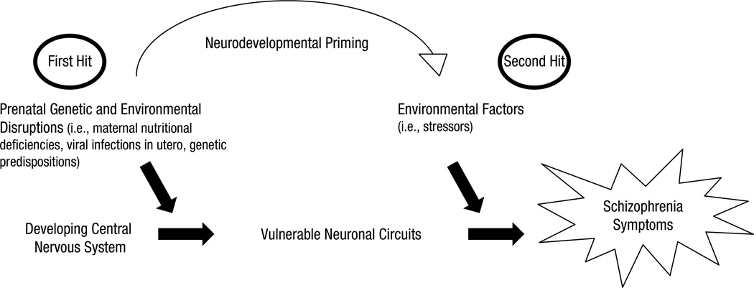

MATERNAL IMMUNE ACTIVATION
Neurodevelopmental structure is influenced by both genetics and the gestational environment, with the latter ruling execution of neurodevelopmental blueprint. During pregnancy, the maternal immune system plays a unique dual role of tolerating the semi-allogeneic fetus while being prepared to protect the mother and fetus from invaders. If the mother is infected by either a bacterial or a viral infection or has an autoimmune disease flare-up that requires a maternal immune response, her body will mount a strong and systemic reaction known as Maternal Immune Activation (MIA). There is considerable epidemiological research demonstrating MIA during specific gestational windows significantly increases risk for neurodevelopmental disorders in children (Tang et al., 2025). The pro-inflammatory cytokines, specifically Interleukin-6 (IL-6) and interleukin-17a (IL-17a), are the primary mediators of this process. The mother’s immune response releases these cytokines into the mother's bloodstream. While the placenta is an effective barrier preventing direct infection from maternal agents, it is influenced by maternal inflammation. High levels of maternal cytokines can influence the function of the placenta, stimulate the placenta to release secondary inflammatory mediators into the maternal compartment, or, in some cases, these mediators may cross the maternal-fetal barrier into the fetus’s compartment.
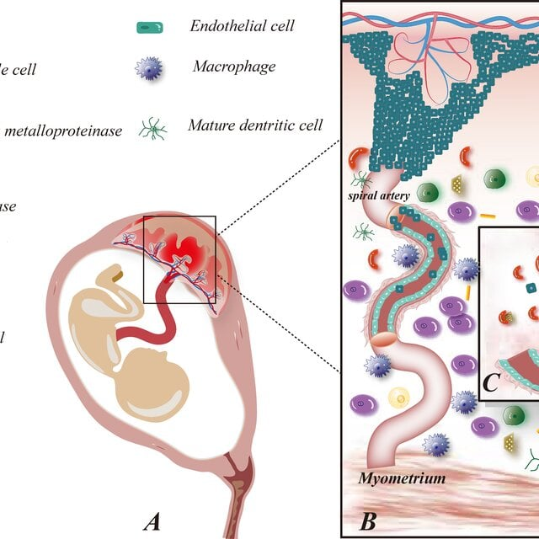
These immune signals disturb the normal development of the fetal brain. For example, increased levels of IL-6 (an immune signal) before birth lead to increased density of glutamatergic synapses and disturbed connections in the hippocampus, which is critical for learning and memory. Similarly, IL-17a directly affects the growth of the cortex by causing abnormal changes in the way neurons develop from progenitor cells. In addition to causing direct damage to neurons, MIA has a very large effect on microglia—the immune cells of the brain. Microglia play an important role in eliminating weak synaptic connections by pruning them so that cognitive function can work better. Maternal immune activation (MIA) can cause early or extended activity of microglia, resulting in excess pruning of weak and insufficient pruning of strong synapses to lead to unusual levels of connectivity for ASD. The different physiological impacts of MIA on male and female fetal development may explain why ASD is more commonly diagnosed in boys. Evidence shows that male and female fetuses react differently at the molecular and behavioral levels to the same maternal immune event during pregnancy (Xu et al., 2024). The maternal–fetal immunological conflict contributes to impaired neurobehavioral development, with males suffering from significantly greater levels of impairment. Evidence shows this disparity is partly due to sex based differences in the regulation of maternal inflammatory factors by placentas and fetal glial cell activation (Sanchez-Martin et al., 2026). In addition, research indicates that MIA can cause long-term changes in the gut microbiome of offspring, and therefore the prenatal inflammation associated with MIA is believed to be a major contributing factor to gut–brain axis disruption that is often associated with ASD(Tartaglione et al., 2022). A recent systematic review by Tan et al. (2025) supports the notion that the pathophysiological relationship between MIA and neurodevelopmental disorders in offspring is mediated primarily through specific neuroinflammatory pathways disrupting fetal brain development during critical periods of gestation.

KEY STUDIES ON THE RISK OF AUTISM
Interleukin-6 (IL-6) is one of the most studied mediators of Maternal Immune Activation (MIA). According to Mirabella and colleagues (2021), elevated levels of maternal IL-6 throughout pregnancy can disrupt the development of synaptic structures (i.e., by preferentially facilitating the creation of glutamatergic synapses) and change connectivity within the hippocampus in the developing fetus. These structural changes may create the neurological basis for the sensory processing challenges and cognitive impairments commonly associated with autism spectrum disorder (ASD). Similarly, Tartaglione and others (2022) used mouse models to show that immune activation during pregnancy gives rise to autism-like behaviours, as well as ongoing neuroinflammation in postnatal offspring. This work also showed that there were alterations in gut microbiota in the postnatal offspring, therefore providing further evidence of the role of the gut-brain axis in the pathophysiology of ASD.
Using a rat model, Lee et al. (2021) found that male offspring exposed to maternal immune activation exhibited social deficits, decreased neural connections, and microbiome patterns comparable to those found in autism. The presence of structural abnormalities associated with ASD (such as hypomyelination, or a lack of the development of the myelin sheath around neurons), provide an explanation of the reasons for the slow processing of information within the brain found in individuals with ASD. Ji et al. (2025) showed that cognitive deficits arising from maternal immune activation in rat models are not necessarily permanent. Males exposed to maternal immunologic alteration during pregnancy and resulting birth defects demonstrated significantly more severe inflammatory reactions in response to these maternal cytokines, as well as greater behavioural problems than females exposed to maternal immunologic alteration. Hence, the gender of child may affect their development when faced with maternal inflammation at the maternal-fetal level and should be taken into consideration when evaluating birth defects. Sanchez-Martin et al. (2026) showed that fetal immune conflict directly contributes to male-specific impairments in neurodevelopmental models. This provides a biological basis for why ASD is diagnosed at much higher rates in human males than in females.
Changes to microglial function represent a central mechanism for sustained behavioural and structural deficits. Microglia are the central nervous system's primary immune cells and the chief sculptors of synaptic connections. Scholz et al. (2024) explained that epigenetic mechanisms regulate microglial immune responses, and maternal immune activation (MIA) may create maladaptive epigenetic changes in microglia, which can prime them for a state of inflammation permanently. The effects of cellular priming by MIA are broad in scope and affect the range of neurodevelopmental and psychiatric diseases. One example is Ormel et al. (2020), who examined microglia-like cells from individuals with autism and found an exaggerated inflammatory response to local neural homeostasis. Microglia that are highly reactive due to epigenetic locking from prenatal MIA severely decrease their ability to prune synapses. New studies using human cellular models to overcome the constraints of animal studies have emerged. Gomes et al. (2022) used induced-pluripotent stem cells (iPSCs) derived from both autistic and neurotypical individuals to study how the cytokine IL-17a affected neural progenitors. IL-17a exposure induced atypical neuronal differentiation in both groups of iPSCs.
Most importantly, the stem cells derived from autistic subjects responded differently to the immune challenge than those from neurotypical controls, offering compelling in vitro evidence that human neural cells harbor intrinsic genetic vulnerabilities that dictate their response to environmental inflammatory insults. The intrinsic genetic vulnerabilities that dictate these cellular responses are highly complex. As Levchenko et al. (2021) identified through genome-wide association studies (GWAS), extensive gene networks associated with severe psychiatric and neurodevelopmental disorders are deeply intertwined.

GENE-ENVIRONMENT INTERACTION: GENETIC RISK
As outlined by the "Dual-Hit" Hypothesis, the interaction of genetic mutations and Maternal Immune Activation (MIA) greatly influences the pathophysiology of Autism Spectrum Disorder (ASD) by regulating both of these types of influences via a gene-environment (G x E) interaction through complex epigenetic and molecular processes. Epigenetics refers to the various chemical modifications (e.g., DNA methylation, histone acetylation) that can occur on DNA or chromatin. Through these epigenetic modifications, gene expression can be altered without changing the underlying genetic code. Environmental stressors during the prenatal period, including systemic MIA, can create long-lasting epigenetic changes to the developing fetal genome. As demonstrated by the fact that the immune response of microglia is tightly regulated through epigenetic processes, MIA-induced epigenetic alterations that occur during gestation may leave the microglia of the offspring in a permanent "primed" or dysfunctional state. Thus, if a fetus already has a genetic mutation/immune dysregulation (the first hit) and has a MIA-induced epigenetic change to microglial function (the second hit), it may severely disrupt synaptic pruning and result in a state of neural dysregulation. As evidenced in patient-derived microglia-like cells obtained from individuals with significant neurodevelopmental or psychiatric disorders, the dysregulation and subsequent molecular variability attributable to the above-mentioned processes are staggering; microglial-like cells derived from these patients exhibit increased pro-inflammatory responses (i.e., increased reactive inflammation) (Ormel et al. 2024).
Furthermore, in order to fully understand the passage of maternal signals of inflammation to, and their interaction with, the fetus on a genetic level, the need for exploration of new ways for cells to communicate with each other is required. There is mounting evidence for the role of extracellular vesicles (including exosomes) in transmitting both inflammatory signals and regulatory signals to other cells. In systemic disease pathology, exosomes produced by tumours can carry highly potent molecular cargo throughout the body and modulate distant physiological sites, as well as the cellular environment (Bai et al, 2022). In reference to neurodevelopment, it is increasingly being suggested that exosomes derived from the mother or from the placenta may be major vehicular transporters of pro-inflammatory cytokines and/or epigenetic modifiers across the maternal-fetal interface. Once there, and once inside the genetically at-risk fetus, inflammatory exosomes will bypass traditional protective barriers and will directly affect the developmental trajectory of neural progenitor cells.
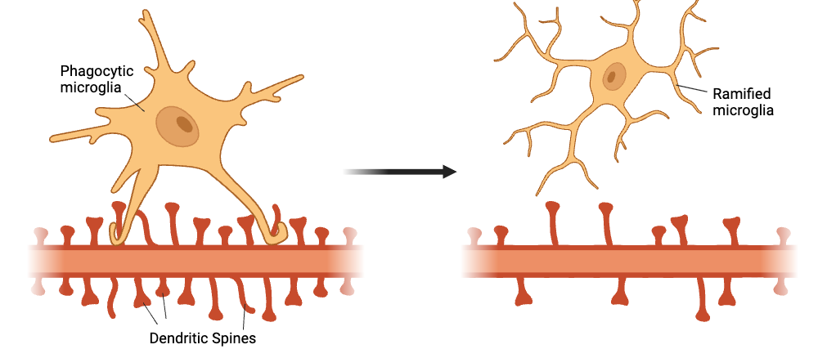
The genetic ability of the unborn fetal brain to resolve inflammation adds to the already complex nature of the interaction between genes and environment (G x E). As a fetus typically develops along a neurodevelopmental timetable, an inflammatory challenge (for example) provokes and stimulates a variety of pro-resolving molecular pathways to neutralize inflammation, promote tissue repair, etc. For example, specialized lipid mediators known as pro-resolving lipid mediators (like Maresin 1) actually stimulate regeneration of nerves and help reduce neuroinflammation subsequent to the occurrence of structural neural injury (Wei et al., 2022). However, in the ASD context, the many chronically neuroinflammatory postnatal brains (Willmott et al., 2022) seem to indicate that there is a massive failure in these resolution pathways. Evidence strongly suggests that the extensive and intricate gene networks associated with psychiatric/neurodevelopment vulnerability (Levchenko et al., 2021) not only make it more likely that a person will suffer from an initial injury, but also impede the ability of an unborn fetus's brain to both produce and respond to pro-resolution mediators such as Maresin 1. Therefore, the genetic risk associated with ASD is a double whammy in terms of harm caused by exposure to maternal cytokines (such as IL-6, IL-17A, etc.) and damage repair by cellular mechanisms required to repair neural injury following exposure to those maternal cytokines.

GAPS IN RESEARCH
Despite progress in understanding how genetics and environment interact, there remains a significant gap in the current neurobiological literature. First, while murine models have successfully replicated acute ASD-like phenotypes, translating these findings directly to human clinical populations remains inherently challenging. This is because mice and humans develop at different rates, have different placenta structures, and have different brain complexities. A key question is how problems during pregnancy, like system issues affect individuals across the entire lifespan. The most research on Maternal Immune Activation (MIA) focuses on how it affects children’s brain development and early behavioral problems. However, adolescents with neurodevelopmental vulnerabilities frequently present with compounding secondary phenotypes that dramatically affect their quality of life.For example many teenagers have trouble sleeping which can have effects on their long-term mental health, ability to focus and emotional well-being. It is unknown if brain changes caused by MIA during pregnancy such as those found by Lee et al. (2021) lead to sleep problems in teenagers. Linking early pregnancy brain inflammation to psychiatric and physical problems is an important area for future studies. These studies will help us understand how early life experiences shape human mental and physical health over time.
Moreover, gaps exist in terms of exploring the therapeutic interventions and neuroplasticity following an MIA event (Mother with Inflamed Anemia during Pregnancy. Researchers have clearly shown there are structural and functional deficits caused by MIA but only a few studies have looked at how a postnatal environment might alleviate some of this damage after birth. A recent study utilizing rat models by Ji et al. (2025) provided compelling evidence that highly enriched postnatal environments could significantly reverse early onset cognitive and memory deficits in female rats. From these findings there is an important void in our understanding of how neuroplasticity can be applied after birth to reverse birth defect caused by nerves and if we could identify the best types of behavioral or pharmacological programs for vulnerable human populations should be very high on the priority list for future research efforts. The potential utility of Pro-resolving mediators to actively clear neuroinflammation in the developing brain adds another needed paradigm shift in the direction of ASD research. Currently most of the literature supports that there are large COVID-19 differences based on sex differences regarding biological responses to MIA (Xu et al., 2024; Sanchez-Martin et al., 2026); however, overall why female fetuses are more protected than males due to the chromosomal, hormonal or placental mechanisms is still largely unknown. Continued and detailed examination of the biological “shield” contributing to a female fetal immunocompetent response against maternal-fetal immune conflict may lead to the development of novel preventative measures for all pregnancies at risk for developing severe maternal systemic inflammatory responses.

CONCLUSION
Autism Spectrum Disorder's (ASD) etiology is an extraordinarily intricate biological mystery that firmly discounts any single-variable explanation for its origins. As discussed throughout this paper, the primary driving force behind the pathophysiology of ASD is a combination of genetic vulnerabilities, and environmental exposures prior to birth, which interact greatly and destructively with one another to create the disorder. One of the major contributors to developmental disruption is maternal immune activation; during periods of extreme maternal inflammation, pro-inflammatory cytokines (ie: IL-6, IL-17a) located in the maternal circulation cross into the foetal environment, leading to a premature maturation of microglia, altered epigenetic regulation, and the permanent disruption of the formation of critical neural circuits. Ultimately, the manner in which developmental disruption occurs, and the degree of severity of that disruption are determined by the genetic architecture of the foetus. ASD's "dual-hit" model successfully accounts for ASD's phenotypic heterogeneity, demonstrating why genetic mutations do not all exhibit complete penetrance, and demonstrating why not every maternal infection during gestation will result in neurodevelopmental interference. Polygenic risk networks not only enhance the overall sensitivity of the foetal brain to immune damage but also compromise the ability of the foetal brain to resolve and/or repair injury resulting from a gestational cytokine storm.
It is crucial for the scientific community to acknowledge that the gene-environment interaction is complex and critical to developing strategies and overcoming existing translational limitations. In order for researchers to move beyond merely mapping the etiology of ASD, they must identify major gaps in the literature, especially as it relates to longitudinal assessment of adolescent phenotypes, sex-specific mechanisms of protection, and the neuroplasticity of a child when raised in an enriched postnatal environment. Ultimately, identifying the specific intersection between the individual’s genetic vulnerability and their neuro-immune profile will create opportunities for the use of precise, individualized, targeted therapeutic solutions, resulting in better clinical outcomes and quality of life for individuals with ASD.

REFERENCES
Bai, S., Wang, Z., Wang, M., Li, J., Wei, Y., Xu, R., & Du, J. (2022). Tumor-derived exosomes modulate primary site tumor metastasis. Frontiers in Cell and Developmental Biology, 10, 752818. https://doi.org/10.3389/fcell.2022.752818
Gomes, A. K. S., Dantas, R. M., Yokota, B. Y., Silva, A. L. T. E., Griesi-Oliveira, K., Passos-Bueno, M. R., & Sertié, A. L. (2022). Interleukin-17a induces neuronal differentiation of induced-pluripotent stem cell-derived neural progenitors from autistic and control subjects. Frontiers in Neuroscience, 16, 828646. https://doi.org/10.3389/fnins.2022.828646
Ji, M. T., Przybyl, K. J., Harter, A. M., Nemesh, M., Jenz, S. T., Yamazaki, A., Kim, C., Mulligan, M. K., Chen, H., & Redei, E. E. (2025). Early onset memory deficit of WMI rats compared to their nearly isogenic WLIs is reversed by enriched environment in females. Genes, Brain, and Behavior, 24(3), e70027. https://doi.org/10.1111/gbb.70027
Lee, G. A., Lin, Y.-K., Lai, J.-H., Lo, Y.-C., Yang, Y.-C. S. H., Ye, S.-Y., Lee, C.-J., Wang, C.-C., Chiang, Y.-H., & Tseng, S.-H. (2021). Maternal immune activation causes social behavior deficits and hypomyelination in male rat offspring with an autism-like microbiota profile. Brain Sciences, 11(8), 1085. https://doi.org/10.3390/brainsci11081085
Levchenko, A., Kanapin, A., Samsonova, A., Fedorenko, O. Y., Kornetova, E. G., Nurgaliev, T., Mazo, G. E., Semke, A. V., Kibitov, A. O., Bokhan, N. A., Gainetdinov, R. R., & Ivanova, S. A. (2021). A genome-wide association study identifies a gene network associated with paranoid schizophrenia and antipsychotics-induced tardive dyskinesia. Progress in Neuro-Psychopharmacology & Biological Psychiatry, 105, 110134. https://doi.org/10.1016/j.pnpbp.2020.110134
Mirabella, F., Desiato, G., Mancinelli, S., Fossati, G., Rasile, M., Morini, R., ... & Pozzi, D. (2021). Prenatal interleukin 6 elevation increases glutamatergic synapse density and disrupts hippocampal connectivity in offspring. Immunity, 54(11), 2611–2631.
Ormel, P. R., Böttcher, C., Gigase, F. A., Missall, R. D., van Zuiden, W., Zapata, M. C. F., ... & de Witte, L. D. (2020). A characterization of the molecular phenotype and inflammatory response of schizophrenia patient-derived microglia-like cells. Brain, Behavior, and Immunity, 90, 196–207. https://doi.org/10.1016/j.bbi.2020.08.012
Sanchez-Martin, I., Kukreja, B., Henderson, P., Lin, Q., DiMartino, D., Bagan, V., ... & Cheadle, L. (2026). Maternal-fetal immune conflict contributes to male-specific impairments in a mouse model of neurodevelopmental disorders. bioRxiv. https://doi.org/10.64898/2026.02.02.703351
Scholz, R., Brösamle, D., Yuan, X., Beyer, M., & Neher, J. J. (2024). Epigenetic control of microglial immune responses. Immunological Reviews, 323(1), 209–226. https://doi.org/10.1111/imr.13317
Tang, Q., Wang, X., Yang, F., Liang, L., Li, Y., Liu, W., Zhou, R., & Ma, B. (2025). Pathophysiological associations between maternal immune activation and neurodevelopmental disorders in offspring: A comprehensive review. Frontiers in Endocrinology, 16, 1681190. https://doi.org/10.3389/fendo.2025.1681190
Tartaglione, A. M., Villani, A., Ajmone-Cat, M. A., Minghetti, L., Ricceri, L., Pazienza, V., De Simone, R., & Calamandrei, G. (2022). Maternal immune activation induces autism-like changes in behavior, neuroinflammatory profile and gut microbiota in mouse offspring of both sexes. Translational Psychiatry, 12(1), 384. https://doi.org/10.1038/s41398-022-02149-9
Uccella, S., Cordani, R., Salfi, F., Gorgoni, M., Scarpelli, S., Gemignani, A., Geoffroy, P. A., De Gennaro, L., Palagini, L., Ferrara, M., & Nobili, L. (2023). Sleep deprivation and insomnia in adolescence: Implications for mental health. Brain Sciences, 13(4), 569. https://doi.org/10.3390/brainsci13040569
Wei, J., Su, W., Zhao, Y., Wei, Z., Hua, Y., Xue, P., Zhu, X., Chen, Y., & Chen, G. (2022). Maresin 1 promotes nerve regeneration and alleviates neuropathic pain after nerve injury. Journal of Neuroinflammation, 19(1), 32. https://doi.org/10.1186/s12974-022-02405-1
Xu, J., Zhao, R., Yan, M., Zhou, M., Liu, H., Wang, X., Lu, C., Li, Q., Mo, Y., Zhang, P., Ju, X., & Zeng, X. (2024). Sex-specific behavioral and molecular responses to maternal lipopolysaccharide-induced immune activation in a murine model: Implications for neurodevelopmental disorders. International Journal of Molecular Sciences, 25(18), 9885. https://doi.org/10.3390/ijms25189885

