Assignment 5
PH631
- Run the following codes to create a binary BMI variable to identify people who are obese (code as 1 ) using the BMI variables (_BMI5).
data Sasdata_20151 ; set Sasdata_20151;
if _BMI5 = . then bmi_g = .;
else if _BMI5 >=3000 then bmi_g = 1;
else if 1< _BMI5 <3000 then bmi_g = 0; run;

proc freq data = sasdata_20151; table bmi_g ; run;
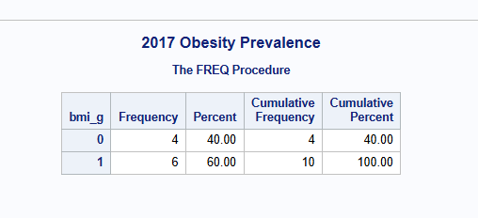

- Create two maps to show the age adjusted prevalence of obesity by US. state in 2015 and 2017
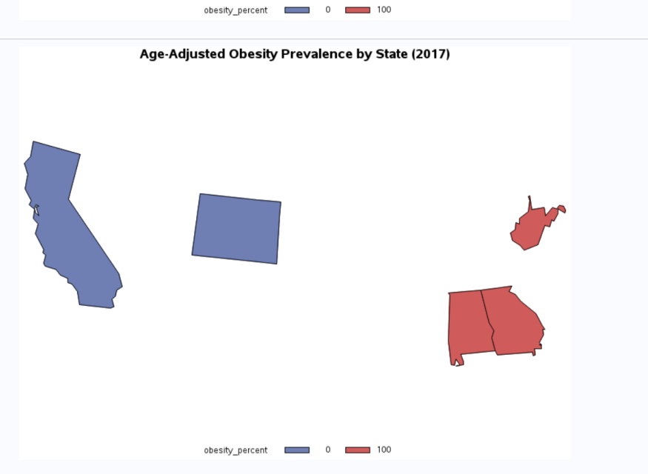
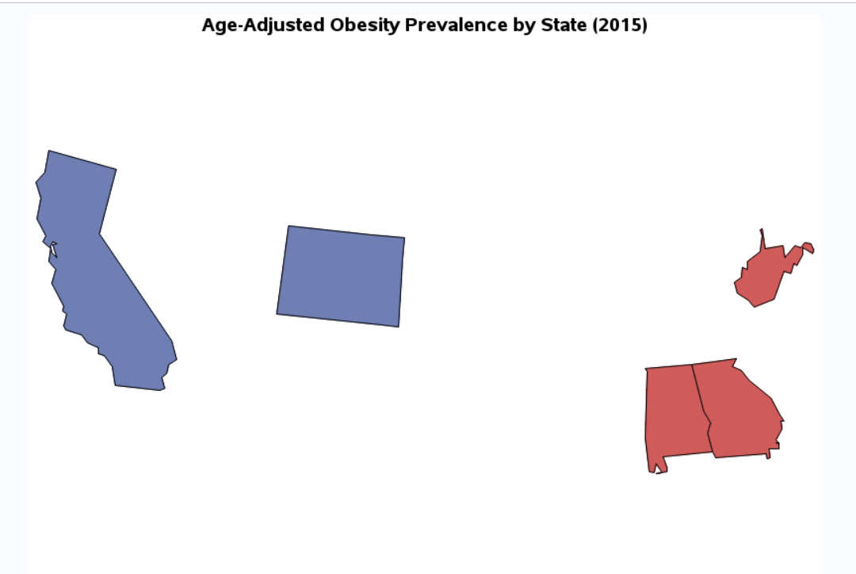
- Provide a paragraph of summary whether any changes happened over the times.
Obesity prevalence in the USA has experienced a considerable growth in its geographical spread from 2015 to 2017. While only a handful of the high prevalence of obesity states existed in both the Midwest and South regions in 2015, there have been a lot more states that are considered to be of high prevalence according to the map for 2017. Also, the number of low prevalence (less than 25%) of obesity has decreased in the two-year period.

